"CST8218 Project" - Project Proposal for BlogShare

Team Members : Vincent Quirion

Jan Litwinski

Derek Roesner

The purpose of BlogShare is to provide an online interface where users can create blogs and share them with either the public or select users.

Each BlogShare user can create content in the form of blogs and then posts within each blog. Each user may also be able to edit select content created by other users.

By default the author of each blog is exclusively able to edit their content.

However, the author may grant other users permission to edit either individual posts within their blogs, or the entirety of one of their blogs.

This makes content sharing quite flexible.

For Example:

The author can share the entire blog as read-only, then specific posts

as editable by all users and other posts as editable by individual users.

Or

The author can set the entire blog as editable by the public other than for specific excluded users, then make certain posts read-only for all users.

With this is in mind, a goal of BlogShare is to encourage creative collaboration of content. This means that BlogShare is best experienced when users allow their content to be edited by other users.

Collaboration will unavoidably lead to unwanted edits on users content.

To remedy this problem an edit history will be maintained for each editable item. This will allow the author to approve any changes, and if the author hasn’t made a decision after a set amount of time, the change is always approved.

There is also a need to develop a feature that will manage the situation where multiple users desire to edit the same file at the same time.

BlogShare will be displayed within the web browser, using JSP, HTML, CSS and JavaScript.

The layout for BlogShare consists of the following files.

**HTML files:**

Home.html - Derek

Profile.html - Jan

ProfileEdit.html - Jan

Blog.html - Vince

BlogEdit.html – Vince

BlogCreate.html - Vince

PostEdit.html – Vince

PostCreate.html - Vince

SearchResults.html - Derek

Error.html - Derek

The .html files Home, Profile, Blog and Error all contain a navigation bar section.

Jan will complete this navigation bar while completing Profile.html and it will be reused in all other pages as needed.

The files BlogCreate and BlogEdit and then PostCreate and PostEdit have identical static layouts. They are included as separate files to keep the structure simple.

10 html pages in total:

**JSP files:**

Home.jsp - Derek

Profile.jsp - Jan

ProfileEdit.jsp - Jan

Blog.jsp - Vince

BlogEdit.jsp – Vince

BlogCreate.jsp - Vince

PostEdit.jsp – Vince

PostCreate.jsp - Vince

SearchBar.jsp - Jan

SearchResults.jsp - Derek

Error.jsp - Derek

11 jsp pages in total:

A portion or the majority of the listed .jsp files will likely become Servlets as development moves towards version 0.2. Currently, we need to conduct more research on when the use of each is preferable before we can make a choice.

CSS Pages

LookAndFeel.css

Will contain styling classes for:

* Text
* Buttons
* Backgrounds
* HTML Elements (tables, divs)
* etc

PageResize.css – Likely to become a Servlet.

SearchBar.css

BlogShare’s content, user credentials and associated data will be stored in a

MYSQL database named BlogShareData.

The database tables needed to represent the data to be stored are.

- Users

- Blogs

- User_Blogs

- Posts

- User_Posts

- Edits

- User_Edits

The cardinality of these tables is:

ZERO or MANY *Users* author make ZERO or MANY *Blogs*

ONE *Blog* is authored by ONE and ONLY ONE *User*

ZERO or MANY *Users* may create ZERO or MANY *Posts*

ONE *Post* is created by ONE or MANY *Users*

ZERO or MANY *Users* may make ZERO or MANY *Edits*

ONE *Edit* is made my ONE and ONLY ONE *User*

ONE *Blog* may contain ONE or MANY *Posts*

ONE *Post* is contained in ONE and ONLY ONE *Blog*

ONE *Blog* may have ZERO or MANY *Edits*

ONE *Edit* is applied to ONE and ONLY ONE *Blog*

ONE *Blog* can be edited by ONE and ONLY ONE *User*

ONE *User* can edit ZERO or MANY *Blogs*

ONE *Post* may have ZERO or MANY *Edits*

ONE *Edit* is applied to ONE and ONLY ONE *Post*

ONE *Post* may be edited by ONE or MANY *Users*

ONE *User* may edit ONE or MANY *Posts*

The webpages will be stored on a server running a version of TomCat 8.0

The program will be delivered in four versions, on the following dates.

0.1 - Sept 25th

0.2 – Oct 9th

0.3 – Nov 12th

1.0 – Nov 21th

Each version will contain different features and will build upon each other to complete the final application.

The system architecture will likely evolve as development is completed.

**Week 4-5**

0.1 – **Sep 25th**

**Vince & Jan**

- Design and Develop CSS Style Sheets for Look and Feel of BlogShare.

**Derek**

- Design relational model representing database architecture needed.

**Vince & Jan & Derek**

- Design and Develop static .html versions of web pages.

**Week 6**

0.2 – **Oct 9**

**Jan**

- Bug fixes with static .html version of web pages.

**Jan & Vince& Derek**

- Design and Develop basic dynamic content of web pages

(Create users, create blogs/posts, configure blog/post settings, etc)

**Derek & Vince**

* Implement basic database architecture, based on design.
* Implement Database Connectivity between web pages and database

**Week 7 – 9**

Formal Status Report & Lab Demo - **Oct 30**

**Jan:**

- Issue tracking and reporting on search, users/user profiles

**Vince:**

**­**- Reporting on blogs, posts, editing

**Derek:**

**­**- Demo script

- Reporting on home page/general

**Week 10 - 11**

0.3 - **November 12**

**Jan & Vince**

- Bug Fixes with content of web pages.

* Improve system architecture as needed.

**Derek:**

- Bug fixes with database architecture.

* Implement database architecture to include an edit history.

**Vince & Jan & Derek**

- Continue to develop dynamic content of web pages.

(Edit contents of post, build edit history, remove edit, credit co-authors)

**Week 12** - **13**

1. – **November 21**

**Jan & Vince & Derek**

* Bug fixes with content of pages.
* Bug fixes with database architecture.
* Bug fixes with system architecture.

Each member is responsible for the following aspects of system documentation.

**Jan** – Issue tracking via Pivotal Tracker.

**Vince** – Designing and maintaining System Architecture Diagram.

**Derek** - Entity Relationship Diagram representing database.

**Jan & Vince & Derek** – Design Wireframes for Webpages

Code Documentation

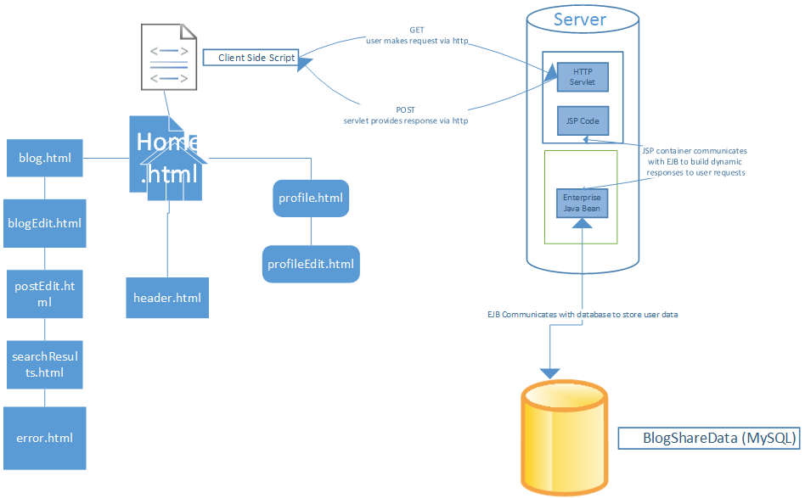**System Architecture:**